DFD

roll 001,045,049,143
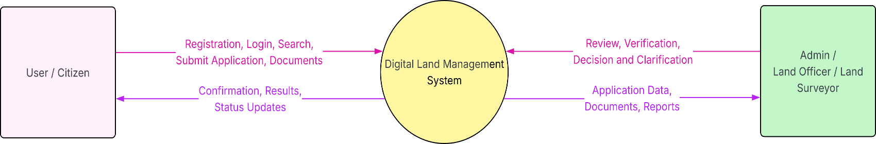
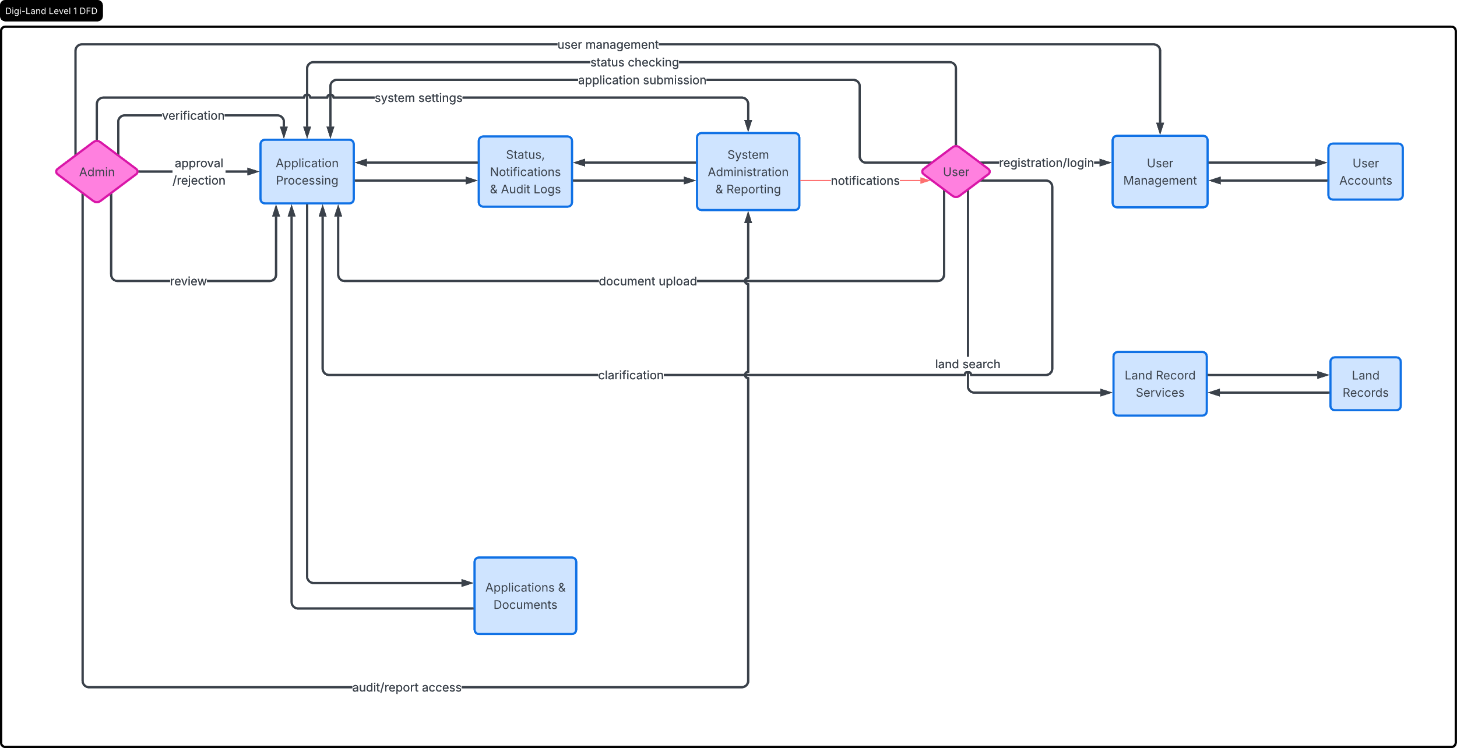
Figure: Level 0 DFD

Figure: Level 1 DFD

